I forgot to mention that I am using a certain formatter in Eclipse.

For your compliance: this is to make sure that our codes will follow the same convention (less eye strain if there is conflict while updating source codes).

You can import my formatter (located in SVN /dev/docs/mnis-cpdv2-java-formatter.xml) in Window → Preferences:

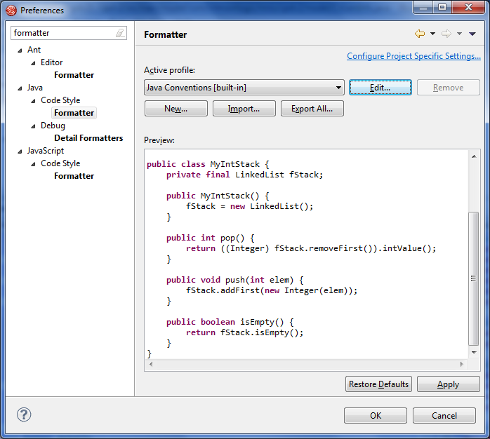

Also if you haven’t changed corrected your indentation as described in the development setup document (Eclipse → Save Actions → Correct Indentation), please change them now.